PRACTICAL 10
- Investigate inode structures using commands such as ls -i, stat, and find. Create hard links and symbolic links and explain their impact on inode allocation.

Design a program using mmap() to perform file reading and writing. Compare memory-mapped I/O with traditional read/write operations in terms of efficiency and implementation complexity.
SOL:-
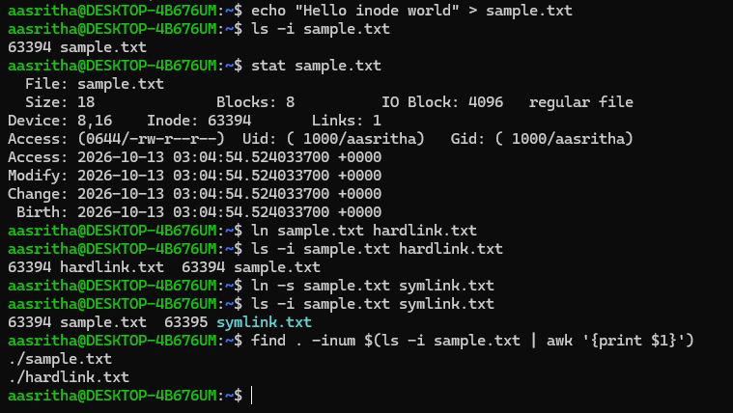
- mmap_demo.c
#include <stdio.h>
#include <stdlib.h>
#include <fcntl.h>
#include <unistd.h>
#include <sys/mman.h>
#include <sys/stat.h>
#include <string.h>

int main() {
const char *filename = "mmap_file.txt";
int fd = open(filename, O_RDWR | O_CREAT | O_TRUNC, 0644);
if (fd < 0) { perror("open"); return 1; }

// Write initial content using write()
const char *text = "Hello using write()!\n";
write(fd, text, strlen(text));

// Get file size
struct stat st;
fstat(fd, &st);

// Memory-map the file
char *map = mmap(NULL, st.st_size, PROT_READ | PROT_WRITE, MAP_SHARED, fd, 0);
if (map == MAP_FAILED) { perror("mmap"); close(fd); return 1; }

printf("File content via mmap: %s", map);

// Modify file via mmap
strcpy(map, "Modified via mmap!\n");

// Sync changes back to disk
msync(map, st.st_size, MS_SYNC);

munmap(map, st.st_size);
close(fd);

return 0;
}
